A000-Eur-Roman-Box Lamp-5 Nozzels-200 CE

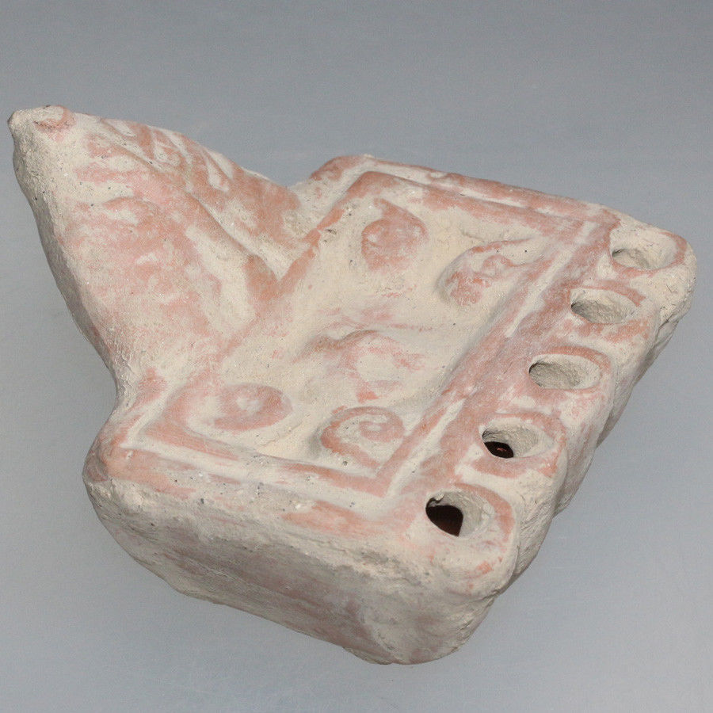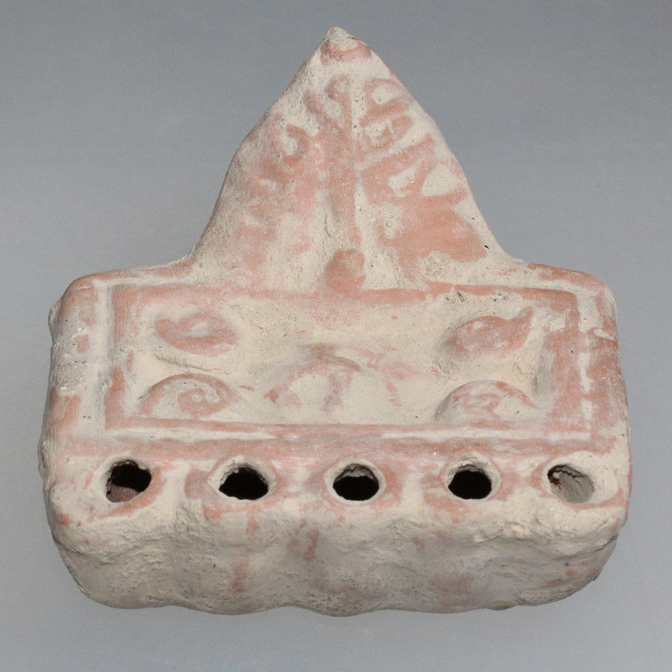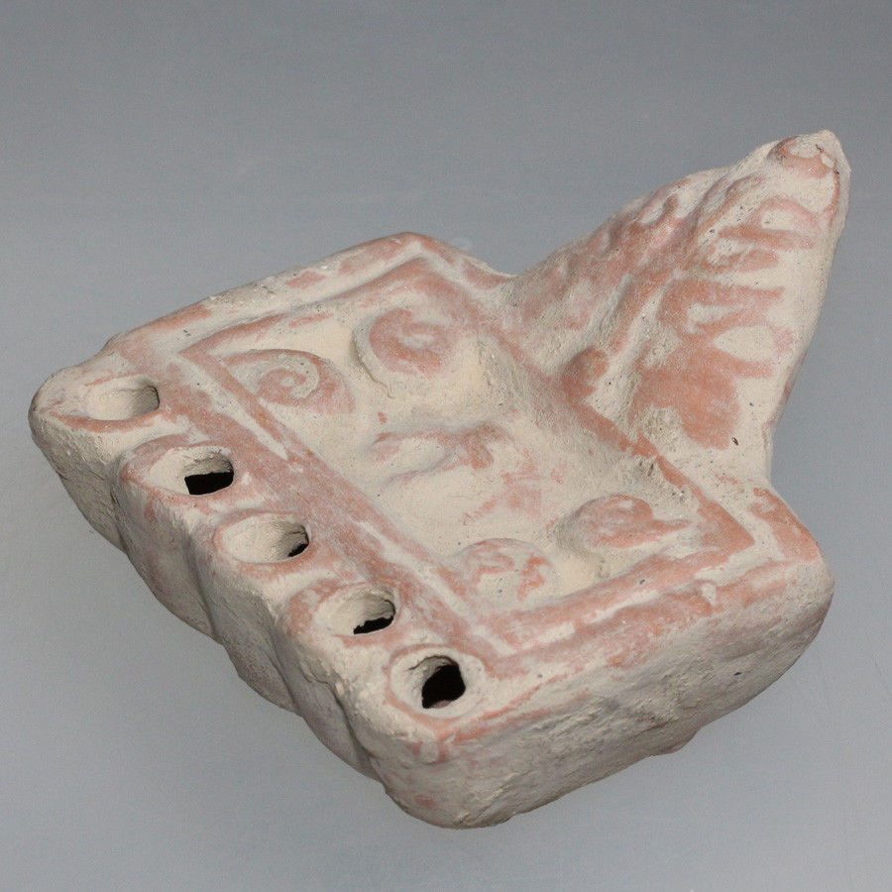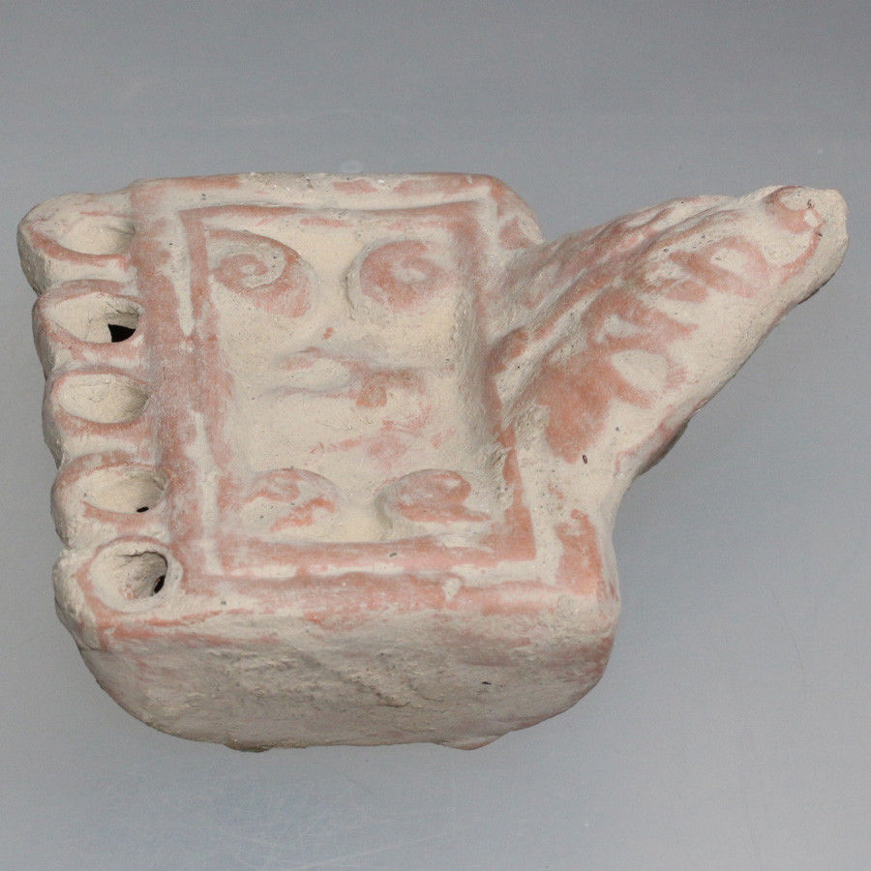

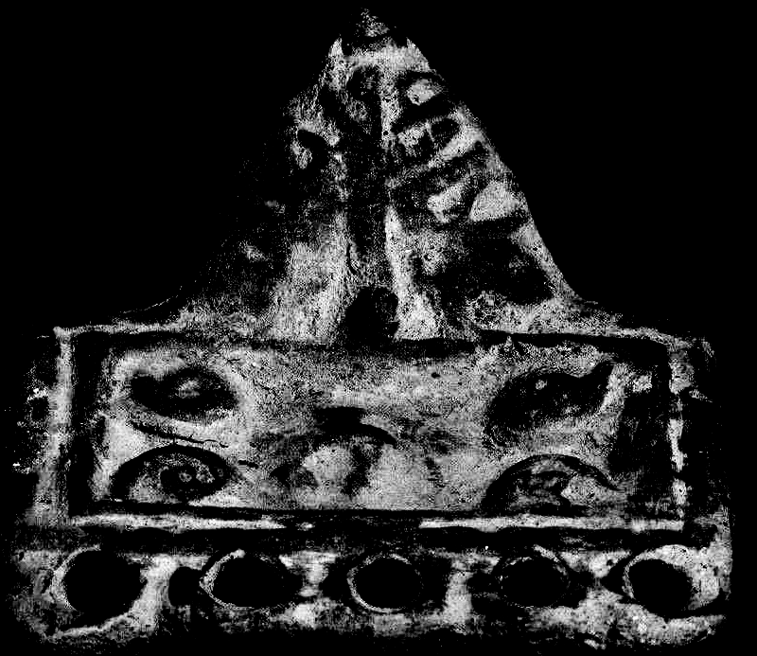

Figs. 1-5. Eur-Roman-Box Lamp-5 Nozzels-200 CE

**Case no.: 4**

**Accession Number:**

**Formal Label:** Eur-Roman-Box Lamp-5 Nozzels-200 CE

**Display Description:**

**Roman Box Lamp with 5 nozzles,** Handle decorated as a leaf.

For the ancient Romans, lamps were more than just a way to be able to see in the dark—they were mythical muses, witnesses to secrets, and instruments of the supernatural. Far more familiar to the average Roman than the high art of mosaics, statues, or frescos, lamps created the atmosphere of day-to-day life in the homes, workshops, and public houses of Roman provincial towns.

It is especially within sanctuaries that we have evidence for their large-scale employment. In the Greek world and in Cyprus a significant growth in the sophistication, scale and proliferation of forms and materials of lamps can be observed from the 7th century BC onwards24. Finely made decorated and occasionally inscribed lamps were frequently dedicated in sanctuaries, from which they were regularly cleared to be deposited in bothroi along with other dedications. Large quantities of lamps were uncovered in some sanctuaries in East Greece, for example at Miletos, Knidos and Halicarnassos;25 more modest yet still substantial numbers were found at Naukratis.26

The integral role of lamps in the cults of the gods meant that new forms were developed for specific use within Greek sanctuaries, such as multiple nozzle ‘sanctuary lamps’ (Fig. 5).27 Lamps were integral to a variety of different ritual practices: as a votive gift to the gods for use during specific rituals such as sacrifices, during oath taking, ritual meals and nocturnal feasts.28 The important role of lamps in funerary rituals meant that they became a significant part of the furniture of burials, something also seen at Naukratis.

**LC Classification:** NB.150.R57

**Date or Time Horizon:**

**Geographical Area:** Balkans, possibly Pannonia

**Map:**

**GPS coordinates:**

**Cultural Affiliation:**

**Media:**

**Dimensions:**

**Weight:**

**Condition:**

**Provenance:**

**Discussion:**

**References:**

Bailey, D.M. 1975, Catalogue of the Lamps in the British Museum 1: Greek, Hellenistic and Early Roman Pottery Lamps, London.

Broneer, O. 1977, Isthmia, 3. Terracotta Lamps, Princeton.

Gardner, E.A. 1888, Naukratis. Part II (Sixth Memoir of the Egypt Exploration Fund), London.

Hogarth, D.G., Edgar, C.C. and Gutch, C. 1898–9, ‘Excavations at Naukratis’, The Annual of the British School at Athens 5, 26–97.

Parisinou 2000, 11–19, 136–9, 162.

Parisinou, E. 2000, The Light of the Gods: The Role of Light in Archaic and Classical Greek Cult, Trowbridge.

25 Selesnow 1997;

Selesnow, W. 1997, ‘Ausgewählte Lampen vom Kalabak- und Zeytintepe’, Archäologischer Anzeiger 1997, 137–43.

T. Szentléleky, Ancient Lamps, Amsterdam, 1969.  
General collection with emphasis on lamps from the region of Hungary.

Appendix:

|  |
| --- |
| Period: Roman   Origin: Balkans, possibly Pannonia   Date: 70 – 200 AD |
| Description:  Box lamp, with three nozzles. Handle decorated as leaf. |

Cf. Szentléleky, 167, 268;